**2.**

**CODING:**

a=imread('kabaddi.jpg');

b=rgb2gray(a);

subplot(2,2,1);

imshow(b);

title('original grayscale image');

subplot(2,2,3);

imhist(b);

title('histrogram of original grayscale image');

j=histeq(b);

subplot(2,2,2);

imshow(j);

title('image after histogram equalization');

subplot(2,2,4);

imhist(j);

title('histogram of image after histogram equalization');

**OUTPUT:**

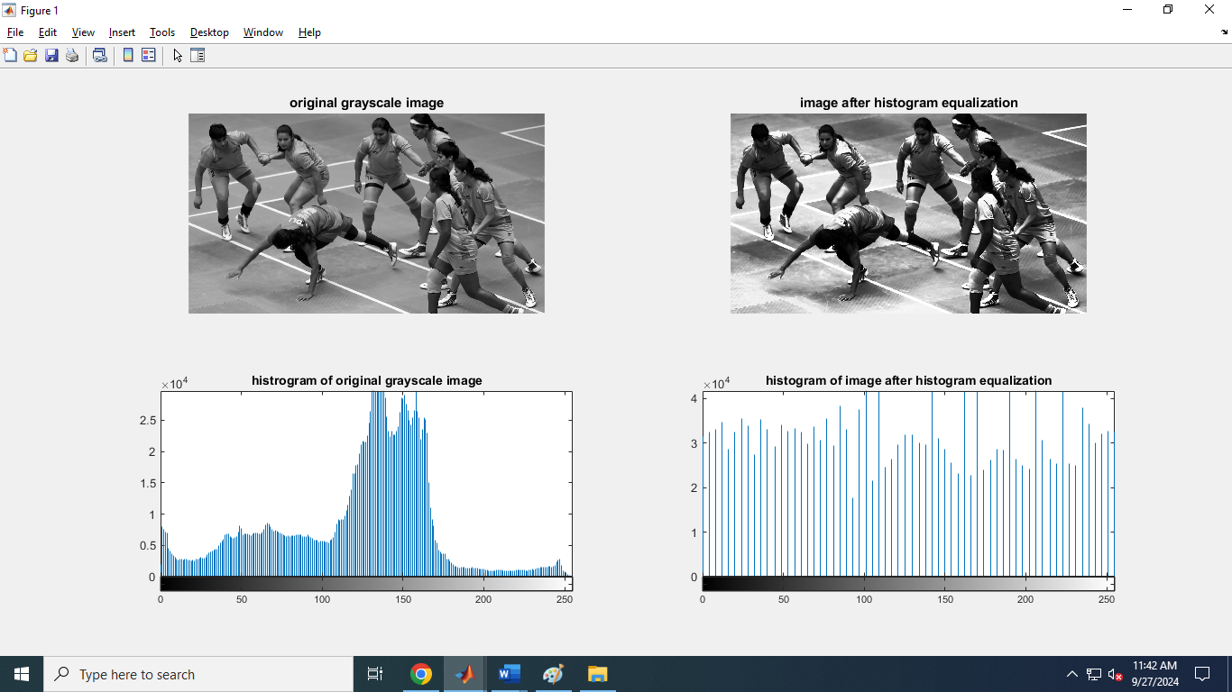

4. **CODING:**

image = imread('monika.jpg');

imshow(image);

title('Original Image');

if size(image, 3) == 3

image = rgb2gray(image);

end

filterSize = 5;

sigma = 2;

h = fspecial('gaussian', [filterSize filterSize], sigma);

filtered_image = imfilter(image, h, 'replicate');

figure;

imshow(filtered_image, []);

title('Filtered Image with Gaussian Blur');

**OUTPUT:**

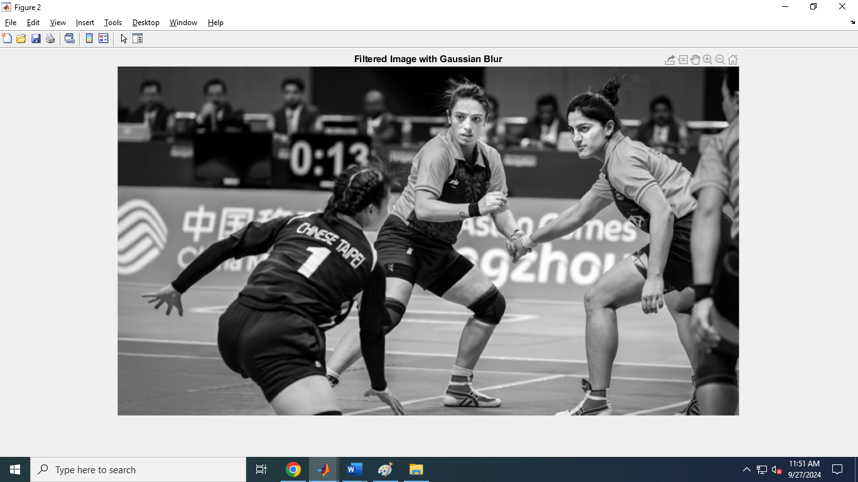

5.

**CODING:**

img = imread('d.png');

grayImg = rgb2gray(img);

robertsX = [1 0; 0 -1];

robertsY = [0 1; -1 0];

edgesX = imfilter(double(grayImg), robertsX, 'replicate');

edgesY = imfilter(double(grayImg), robertsY, 'replicate');

edges = sqrt(edgesX.^2 + edgesY.^2);

imshow(edges, []);

title('Roberts Edge Detection');

OUTPUT:

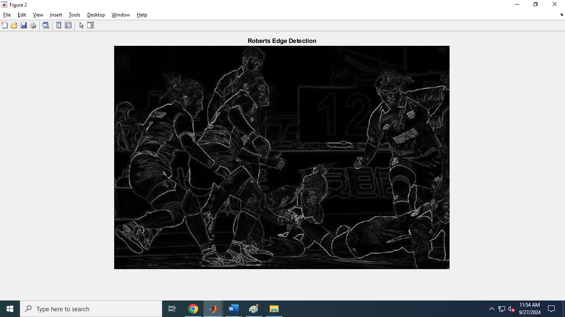

5.2

img = imread('d.png');

grayImg = rgb2gray(img); % Convert to grayscale if necessary

prewittX = [-1 0 1; -1 0 1; -1 0 1];

prewittY = [-1 -1 -1; 0 0 0; 1 1 1];

edgesX = imfilter(double(grayImg), prewittX, 'replicate');

edgesY = imfilter(double(grayImg), prewittY, 'replicate');

edges = sqrt(edgesX.^2 + edgesY.^2);

imshow(edges, []);

title('Prewitt Edge Detection');

output:

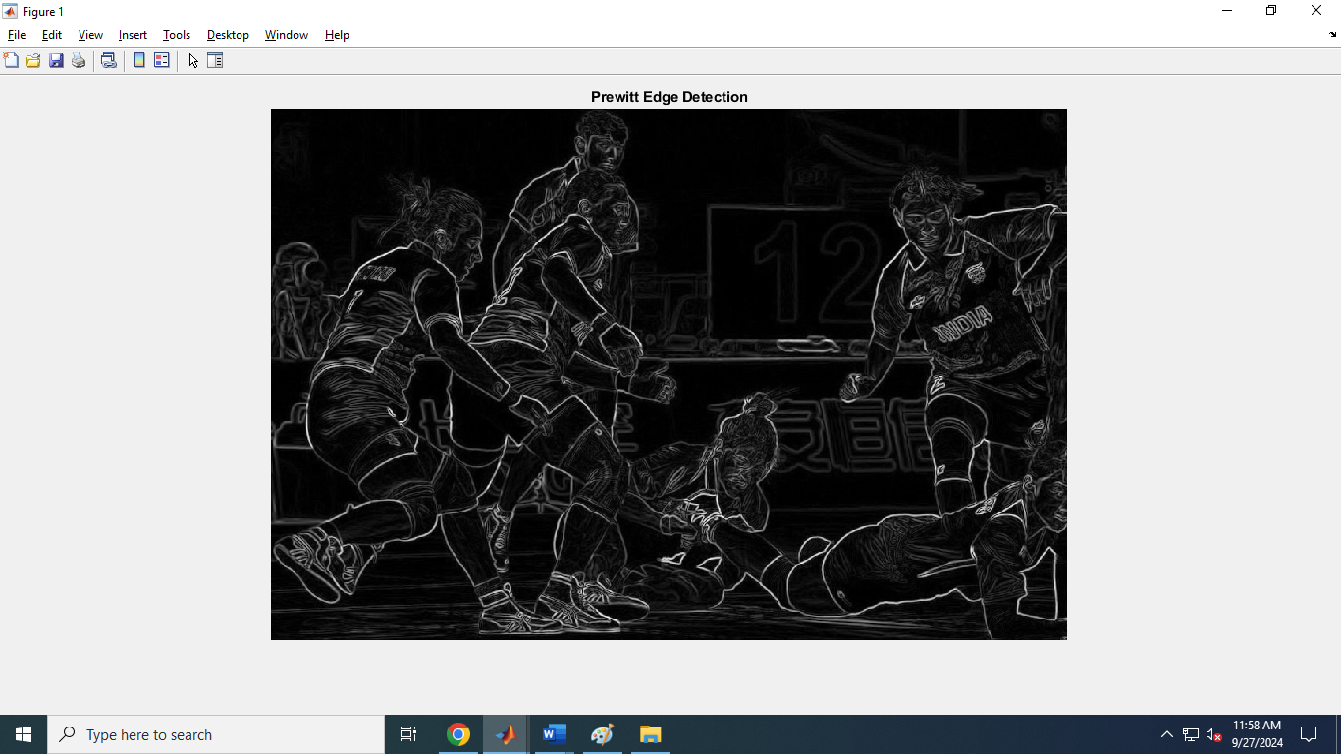

3.

img = imread('d.png');

grayImg = rgb2gray(img); sobelX = [-1 0 1; -2 0 2; -1 0 1];

sobelY = [-1 -2 -1; 0 0 0; 1 2 1];

edgesX = imfilter(double(grayImg), sobelX, 'replicate');

edgesY = imfilter(double(grayImg), sobelY, 'replicate');

edges = sqrt(edgesX.^2 + edgesY.^2);

imshow(edges, []);

title('Sobel Edge Detection');

output:

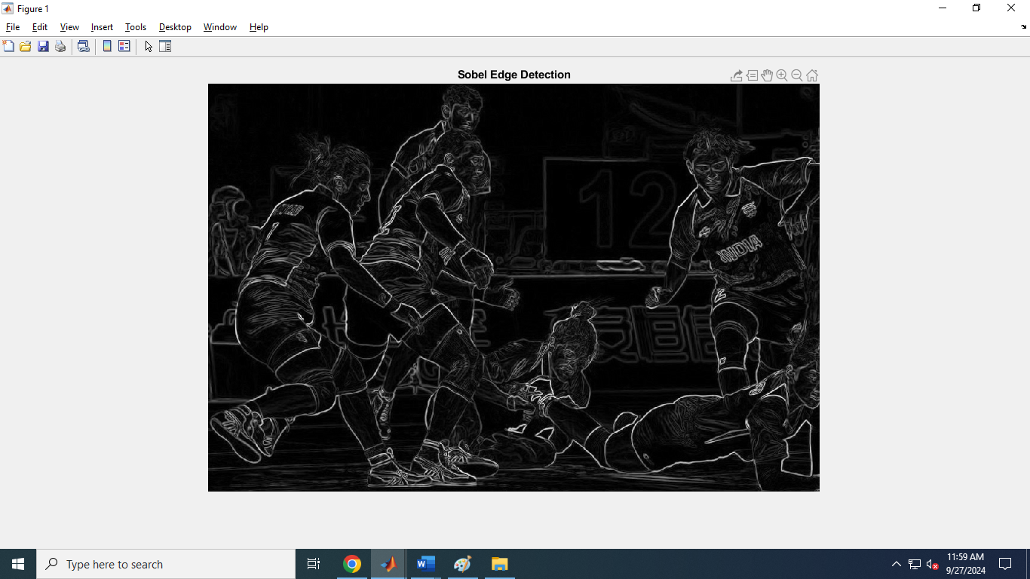

7.

Program:

I=imread('price.png');

background=imopen(I,strel('disk',15));

Ip = imsubtract(I,background);

imshow(Ip,[])

I=imread('rice.png');

Iq = imsubtract(I,50);

figure,imshow(I),

figure,imshow(Iq)

output:

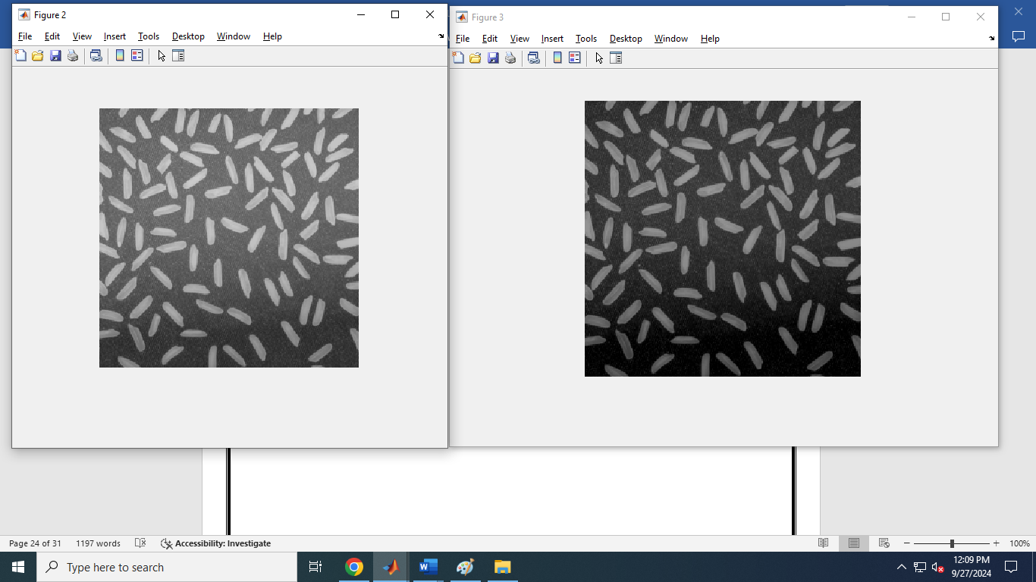

9.

Program:

image = imread('defence.jpg');

threshold_value = graythresh(image);

threshold_image = im2bw(image,threshold_value);

subplot(1,2,1),imshow(threshold_image);

subplot(1,2,2), imshow(image);

output:

